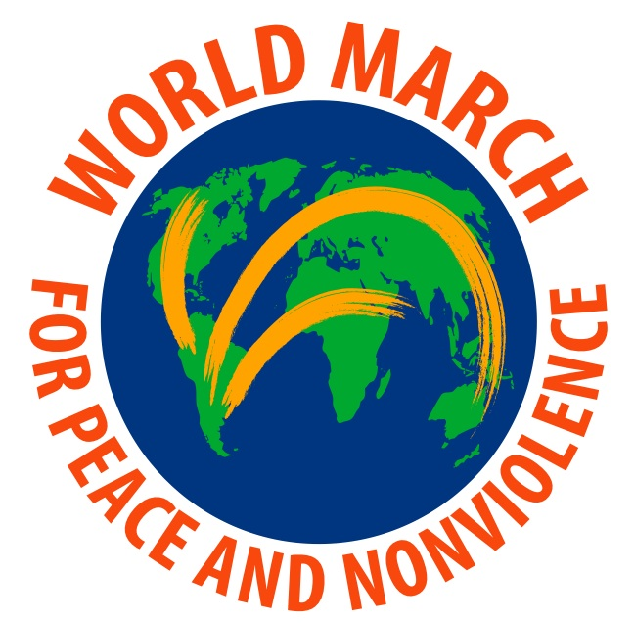  International:  theworldmarch.org  United States:  worldmarchusa.net  New York:  Tel: 212-313-9480  4313 47 Street,  Ste E36  Sunnyside NY 11104  info@worldmarchusa.net  International Coordination;  Mundo Sin Guerras  Rafael de la Rubia,  Director  rafael@marchamundial.org  affiliated with  The Humanist Movement  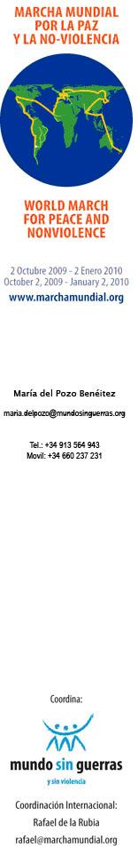 | Dear Friend of Peace & Nonviolence,  I am writing to let you know about an opportunity to participate in an historic event this fall involving thousands of communities and groups around the world like yours.  The World March for Peace and Nonviolence, the world's first 7-continent peace march, is an initiative from the NGO World Without Wars that has garnered international support at the highest levels: Presidents, Nobel Peace Laureates, and hundreds of prominent activists, religious leaders, athletes, actors, artists and musicians. More importantly, the March involves the participation of thousands of organizations and associations and more than one million individuals in 95 countries. All of this energy is being launched with one objective: to generate a global consciousness that condemns all forms of violence (physical, economic, racial, religious, sexual, etc.) and that specifically addresses the mentality that has brought this planet to the brink of perhaps the gravest threat of violence ever known – a nuclear confrontation involving even a few of the 26,000 nuclear weapons in existence today.  The March will consist of two parallel initiatives: between October 2nd, 2009 and January 2nd, 2010, an international team of marchers will cross the planet from New Zealand to Argentina, meeting with heads-of-state, talking to the media, and participating in large local marches and rallies. During this same 3-month period, nonprofit organizations, civic groups, religious congregations, schools and universities, and individuals around the world will do their part by organizing thousands of local events that bring the message of the March to their immediate communities: marches, concerts, workshops, peace walks, cultural, educational and sports events, etc. The goal is to produce a converging diversity of voices calling out for peace and nonviolence and collectively defining the thoughts, feelings, and actions needed to bring us there.  It’s not too late to get involved and add your voice. Here’s how you can participate:  - Endorse the World March by going to our website: www.worldmarchusa.net  - Organize an event or action in support of the March between October 2nd and January 2nd. Activities already being planned include: “Poets for Peace” reading, candlelight vigil, High School Expo, community peace mural, nonviolence film festival, conflict resolution workshops for students, Bike Ride for Peace, forum on the role of the Armed Forces, “Brooklyn Ahimsa” concert, and “Keep Space for Peace Week” demonstrations.  - If you already have an existing event scheduled during these 3 months that you could promote as “In Support of the World March,” please consider adding it to our “93 Days of Peace and Nonviolence” calendar of events.  - Plan an event or action for December 2nd , a “National World March Day,” when the international team of marchers will be in the US. We hope to have events happening to show our support in each of the 50 States and Puerto Rico.  - Spread the word!  I am attaching a brochure on the march and you can also visit our web sites:  www.worldmarchusa.net (US) and www.theworldmarch.org (int’l). If you have further questions, you can contact us at info@worldmarchusa.net or 212-313-9480.  In peace,  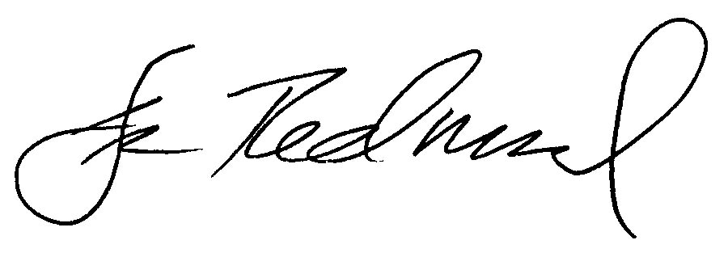  Dennis Redmond  USA Coordinator  World March for Peace & Nonviolence

